
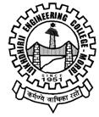
A REPORT on “SSIP 2.0 Sensitization/Outreach Workshop conducted at Sarthak Vidyamandir, Morbi”
Industrial Engineering Department
Date: 12-02-2025
The “SSIP 2.0 sensitization/outreach workshop” was held jointly by by Industrial Engineering and Power Electronics Department for the school students on 12th Feb. 2025 at Sarthak Vidyamandir -Morbi. A total of 333 students (193 students of std.-9 and 140 students of std.-11) attended this program. Dr. H. D. Santoki has conducted this program, elaborated on SSIP 2.0 in brief, explained how it’s beneficial for the students and also discussed main features of SSIP 2.0. Prof. S. N. Gohil assisted for the program. Respected principal Dr. R. K. Mevada sir and HOD Prof. N. N. Garvalia sir and Prof. M. V. Makvana sir encouraged for the program.
Glimpses:
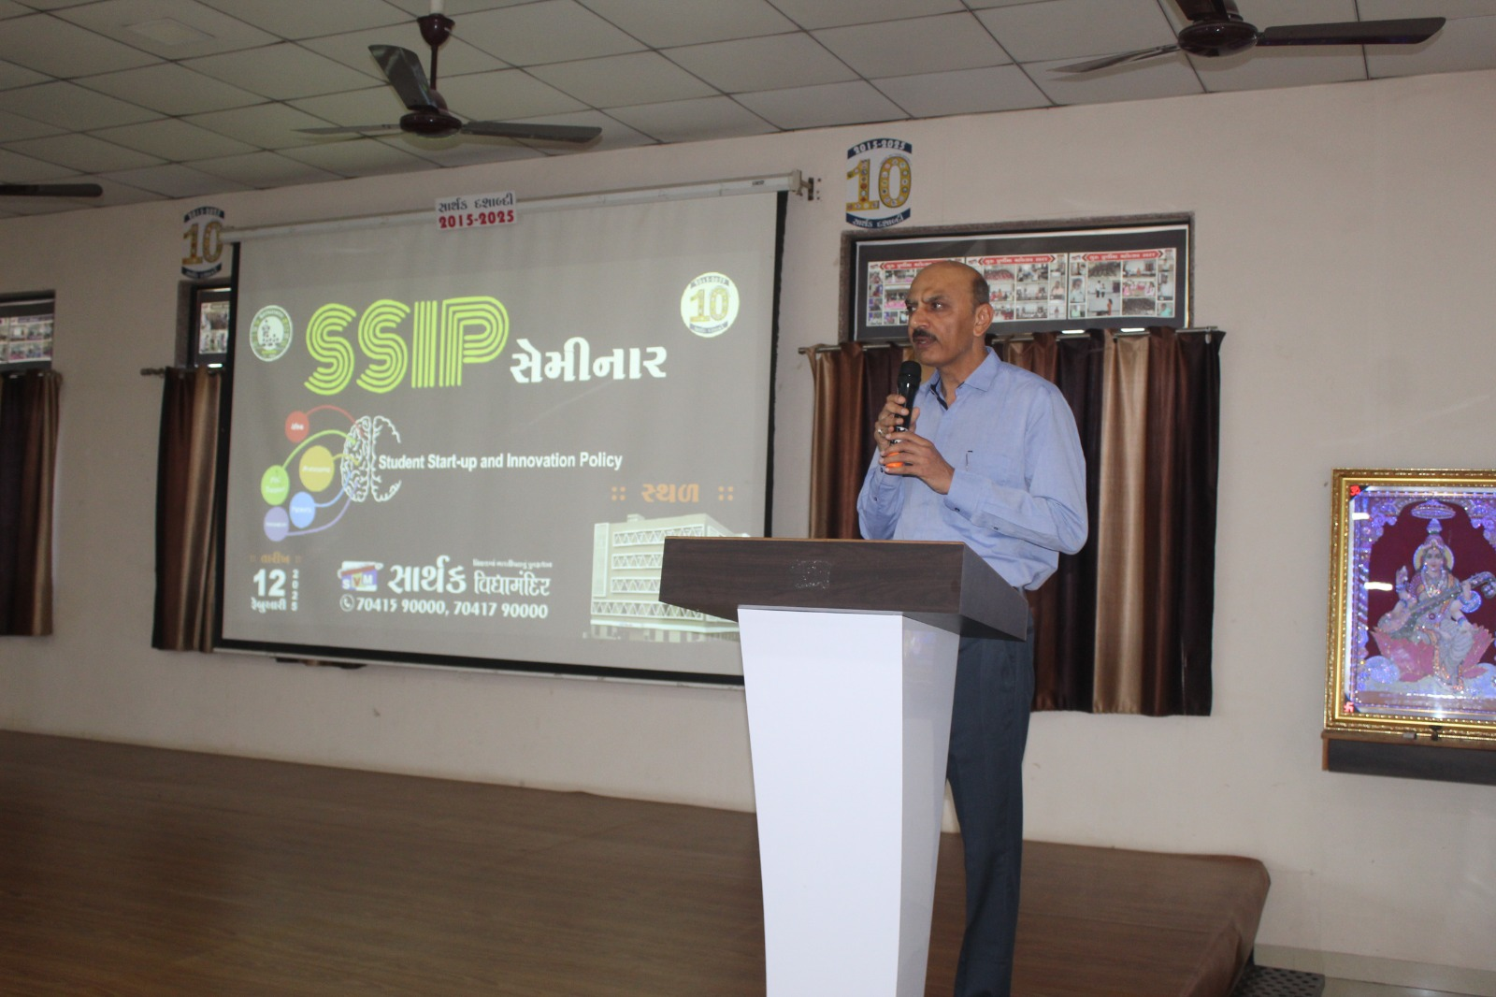 | 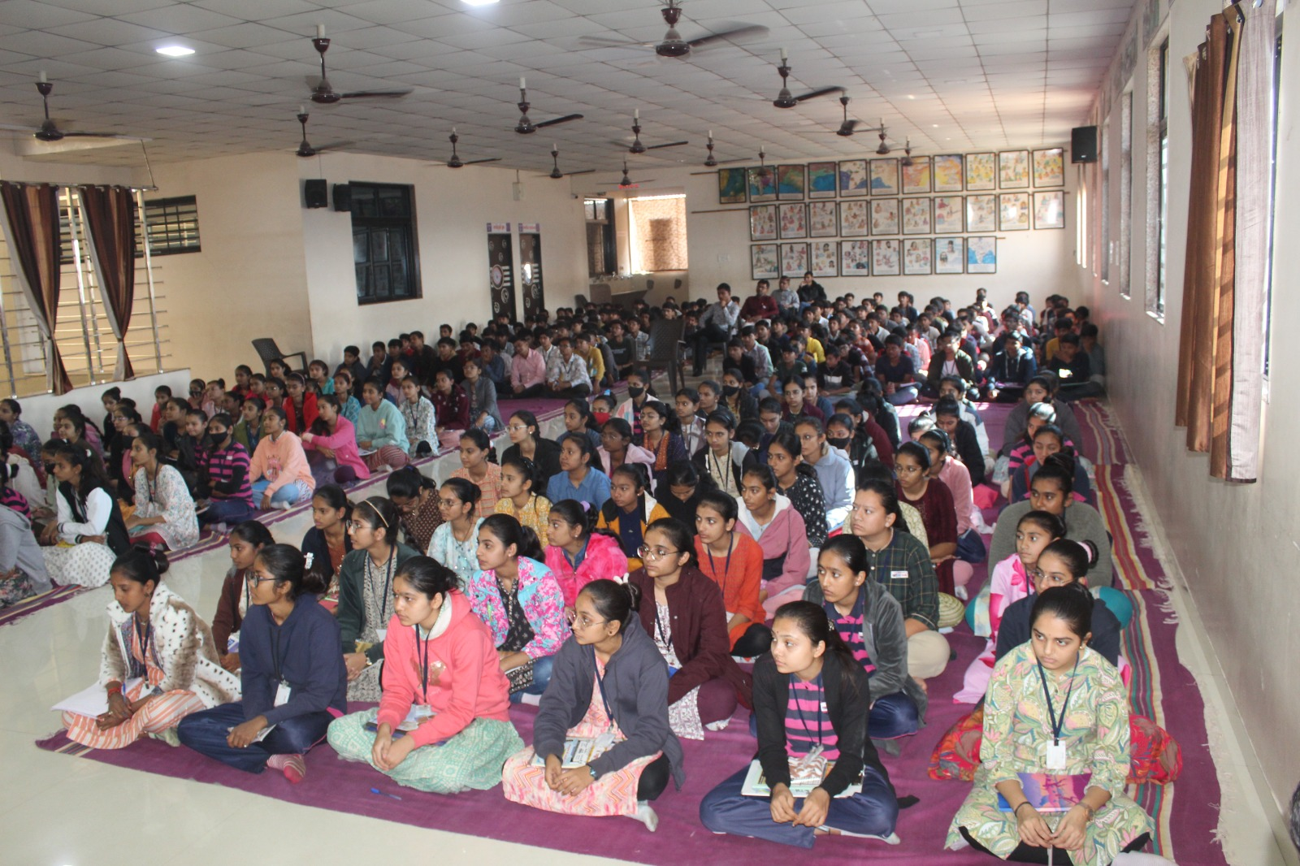
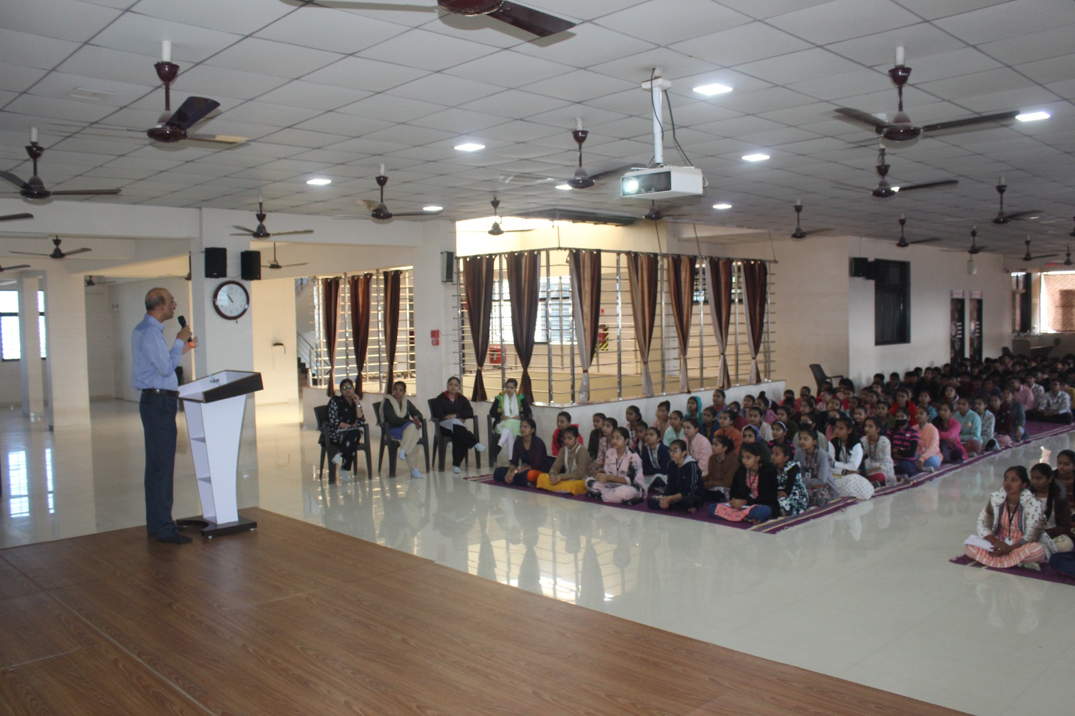 | 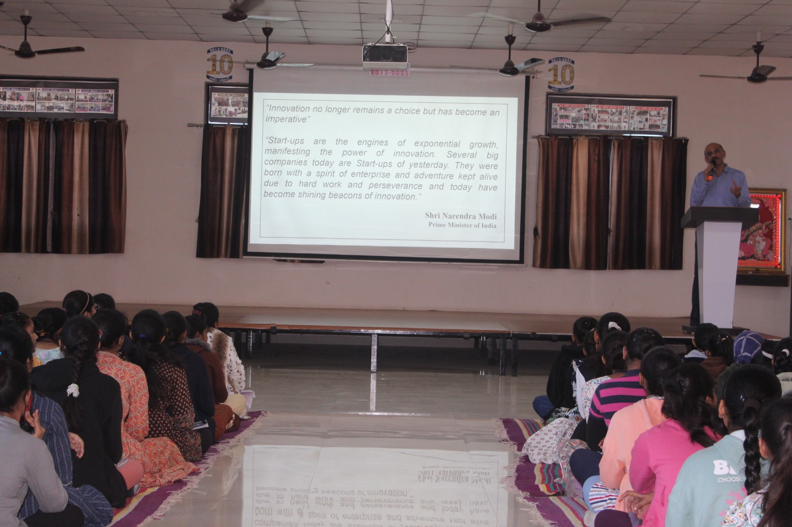
Activity/Event Coordinator (name and sign):
- Dr. H. D. Santoki 2. Prof. S. N. Gohil
HOD (sign & stamp):

